SenseCap: An Obstacle Awareness and Safety Headwear for the Visually Impaired
Hariz Irfan bin Mohd Rozhan (2318583), Tan Yong Jia (2319155), Abdullah Hasan Bin Sidek (2318817), Nur Qistina binti Mohd Faizal (2319512), Department of Mechatronics Engineering, International Islamic University Malaysia. Email: [hrizzirfn@gmail.com]

Abstract
This paper presents the development of SenseCap, a wearable assistive cap made to help visually impaired users move safer and more independently. The system uses multiple sensors to detect obstacles, lighting conditions, colour signals and emergency situations. A light sensor turns on LEDs automatically when it gets dark. Ultrasonic sensors guide the user if something is blocking the path. The MPU6050 detects sudden impacts or falls and sends an alert to a caretaker. There is also an emergency button that sends the user’s location straight to the caretaker for quick help. A colour detection module identifies colours like traffic lights and signs to improve awareness while walking. The system uses a layered architecture where the MCU handles sensors and feedback, while a higher-level unit processes colour detection. Tests show fast response, stable obstacle detection and reliable alerts, making SenseCap a practical and helpful solution for navigation safety.

- Introduction
Safe and autonomous movement is still difficult for visually impaired users, especially when the environment has low lighting, moving obstacles, and head-level hazards [1]. Traditional tools like white canes and guide dogs help with basic navigation, but they mostly detect things on the ground. They don’t tell the user about overhead objects, fast-moving obstacles, or colour-based signals like traffic lights and signs [2]. This makes the user more likely to hit low-hanging structures, walk into branches, or miss important visual cues, which reduces safety and confidence.
To solve these issues, many wearable assistive devices have been developed using sensors and simple feedback systems [3]. Ultrasonic sensors are commonly used to detect obstacles in real time. IMUs help monitor motion and impacts for fall detection. Light sensors can switch on LEDs automatically in dark areas. But even with all these, most systems still can’t detect colours properly, and they don’t include a reliable emergency communication feature for quick response during accidents [4].
Recent improvements in embedded systems allow small colour detection modules to identify traffic light colours and signs [5]. This gives extra information that normal ultrasonic sensors cannot provide. But at the same time, there are challenges like power consumption, speed of processing, and combining multiple sensors without delay or errors.
SenseCap is designed to fix these problems by combining ultrasonic sensors, a light sensor with auto LED control, an MPU6050 impact detector, a colour detection module, and an emergency button that sends the user’s location to a caretaker. The MCU handles real-time sensing and feedback, while the colour detection is processed separately. This setup improves awareness, gives fast alerts, and increases overall safety for visually impaired users.
Table 1 presents a comparison of assistive cap systems that have been developed to support visually impaired users and highlights how they differ from the proposed SenseCap. Wearable assistive headgear has undergone significant development in recent years, shifting from basic obstacle detection to more intelligent and multifunctional systems. Early designs, such as the ultrasonic head-mounted obstacle detection system [6], focused on simple hands-free obstacle awareness using ultrasonic sensors, but were limited by short detection range and the absence of lighting or emergency features. Similarly, the smart cap using ultrasonic and vibration feedback [7] provided tactile alerts for nearby obstacles however, it lacked audio feedback and illumination support, reducing its effectiveness in low-light environments.
More advanced systems introduced camera-based and artificial intelligence technologies. Commercial devices such as OrCam MyEye [8] utilise vision-based object and text recognition to deliver detailed audio descriptions, significantly enhancing environmental awareness, although at a high cost and increased system complexity. Likewise, Envision Glasses [9] employ AI-driven scene interpretation to assist navigation, but require higher power consumption and user training. Other developments, such as IoT-based smart caps [10], integrate mobile applications and wireless connectivity to improve obstacle awareness, though their reliance on smartphones and internet connectivity limits standalone operation. Recent AI vision assistive hats [11] further improve obstacle classification accuracy but involve complex hardware and higher implementation costs. In contrast, the proposed SenseCap prioritises simplicity, affordability, and practical safety by combining obstacle detection with automatic LED lighting and directional audio feedback, making it more suitable for everyday use, particularly in low-light conditions.

Table 1 Table of comparison
Ref/Year | Title | Advantages | Disadvantages | Compared to our proposed
Our Project | SenseCap | Combines obstacle detection, automatic LED lighting, and directional audio feedback; hands-free wearable design, simple operation | No GPS tracking, prototype stage | Balanced and practical assistive cap suitable for daily navigation, especially in low-light environments
[6]  2017 | Ultrasonic Head-Mounted Obstacle Detection System | Simple design, hands-free obstacle detection using ultrasonic sensors | Limited detection range, no lighting or emergency alert | SenseCap provides improved visibility through LED lighting and clearer directional feedback
[7]  2019 | Smart Cap for Visually Impaired Using Ultrasonic and Vibration Feedback | Lightweight wearable, vibration-based obstacle alerts | No audio feedback, lacks lighting assistance | SenseCap offers audio feedback and illumination, improving usability
[8]  2020 | OrCam MyEye | Advanced camera-based vision, real-time audio object and text recognition | High cost; requires user training | SenseCap is more affordable and focuses on essential navigation safety
[9]  2021 | Envision Glasses | AI-based scene description, strong environmental awareness | Expensive; high power consumption | SenseCap is simpler and more energy-efficient
[10]  2022 | IoT-Based Smart Cap for Blind Navigation | Mobile app integration, extended functionality | Dependent on smartphone and internet | SenseCap operates independently without external applications
[11]  2023 | AI Vision Assistive Hat for the Visually Impaired | Accurate obstacle and object classification | Complex system; costly hardware | SenseCap prioritises simplicity and low-cost implementation
- Methodology
2.1 Project Development
Overall, a block diagram is an overview of the entire system such that the connection between input, output and microcontroller can be explained. The project on SenseHat has 3 circuits which are categorized as system 1, system 2, system 3, system 4 and system 5. The block diagram of system 1 (lighting system), system 2 (emergency alert system), system 3 (obstacle detection system), system 4 (fall detection system) and system 5 (colour detection system) is displayed in Fig. 1. The following diagram demonstrates the collaboration of the five mechanisms that secure the efficiency of the project in general. Fig. 2 indicates the flowchart of the system 1, system 2, system 3, system 4 and system 5 that represents the work principle of SenseCap project.

Emergency Button
Ultrasonic Sensor
(sensing obstacle)
Husky Lens
(colour detection)
Node MCU ESP 32
Mobile Phone
Buzzer
MPU 6050
(fall detection)
Speaker
LDR Sensor
(sensing environment)
LED
Fig.1 Block diagram of system 1 (lighting system), system 2 (emergency alert system), system 3 (obstacle detection system), system 4 (fall detection system) and system 5 (colour detection system)
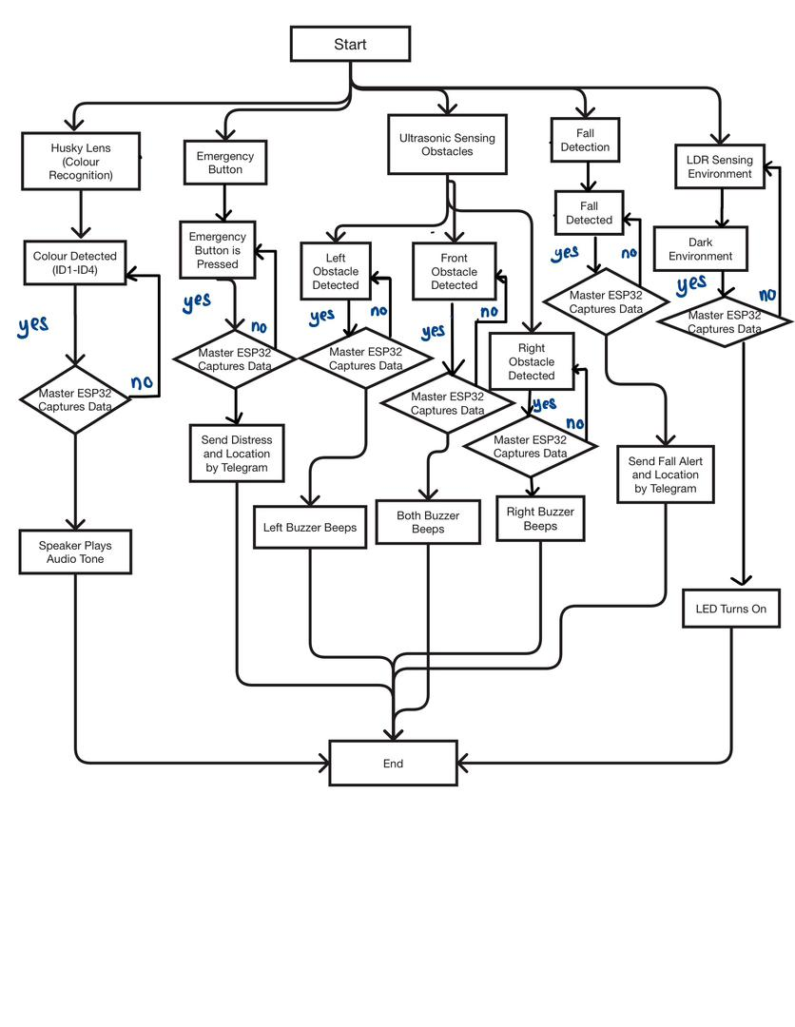
Fig. 2 The flow chart that explains all the work principles for the SenseCap project.

2.2 Schematic Diagram
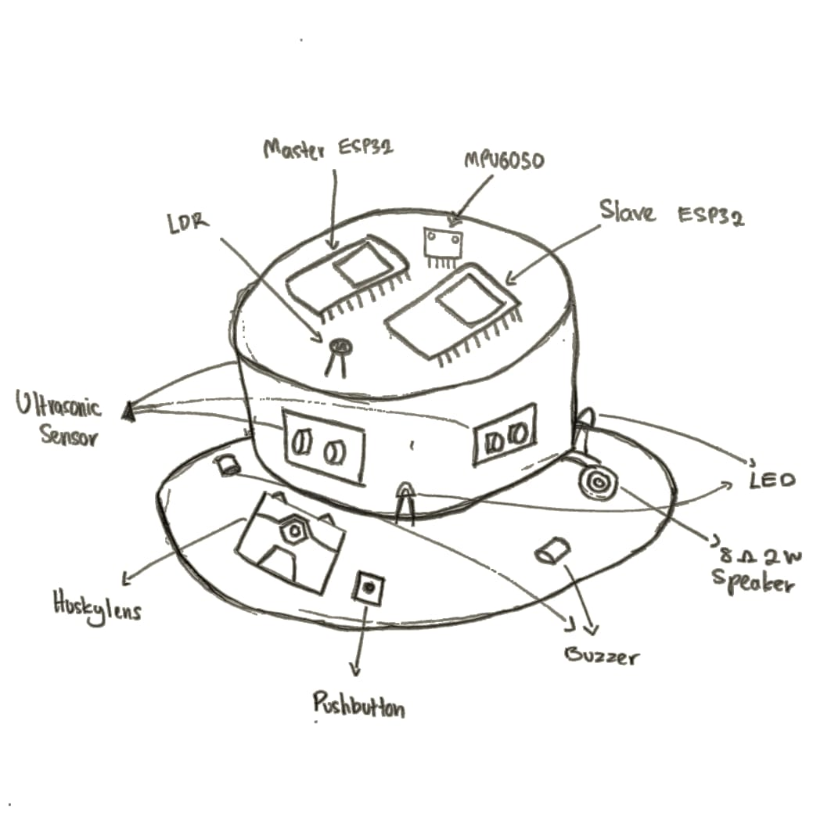
Fig. 3 Sketch of SenseCap
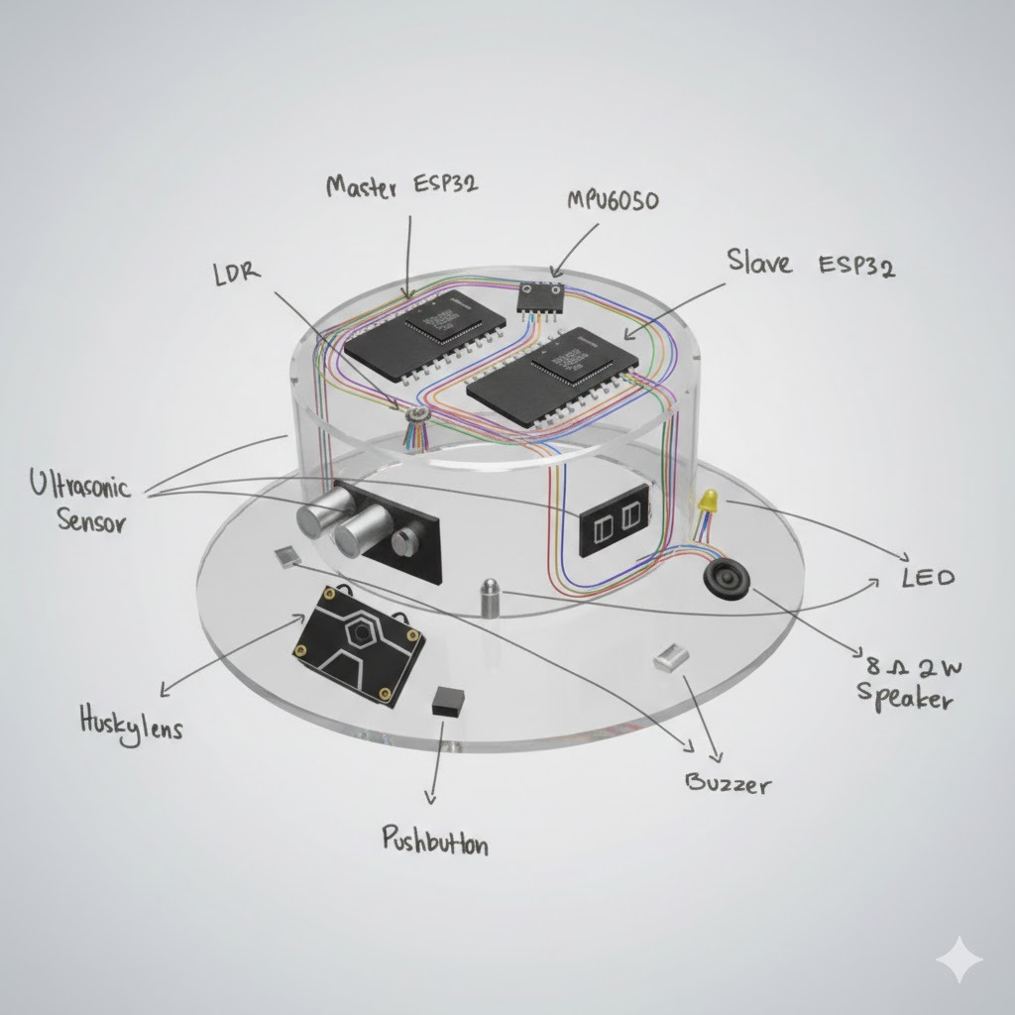
Fig. 4 AI-generated image of the sketch

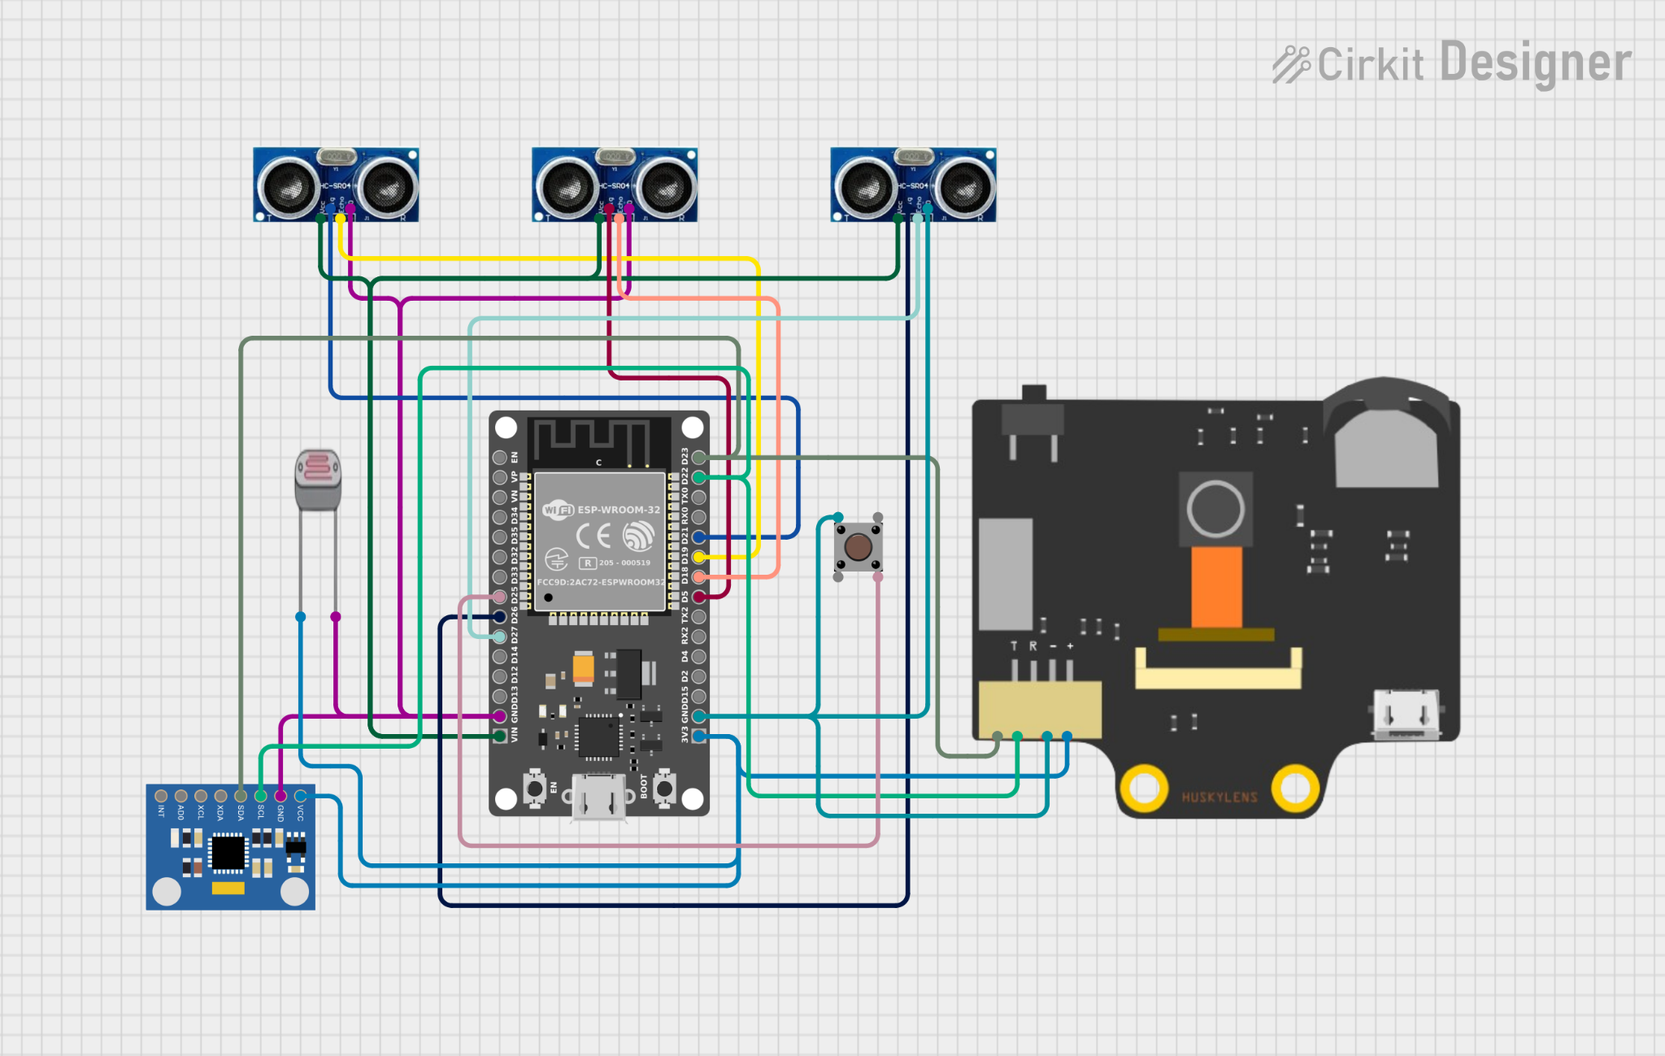
Fig. 5 Master MCU Circuit

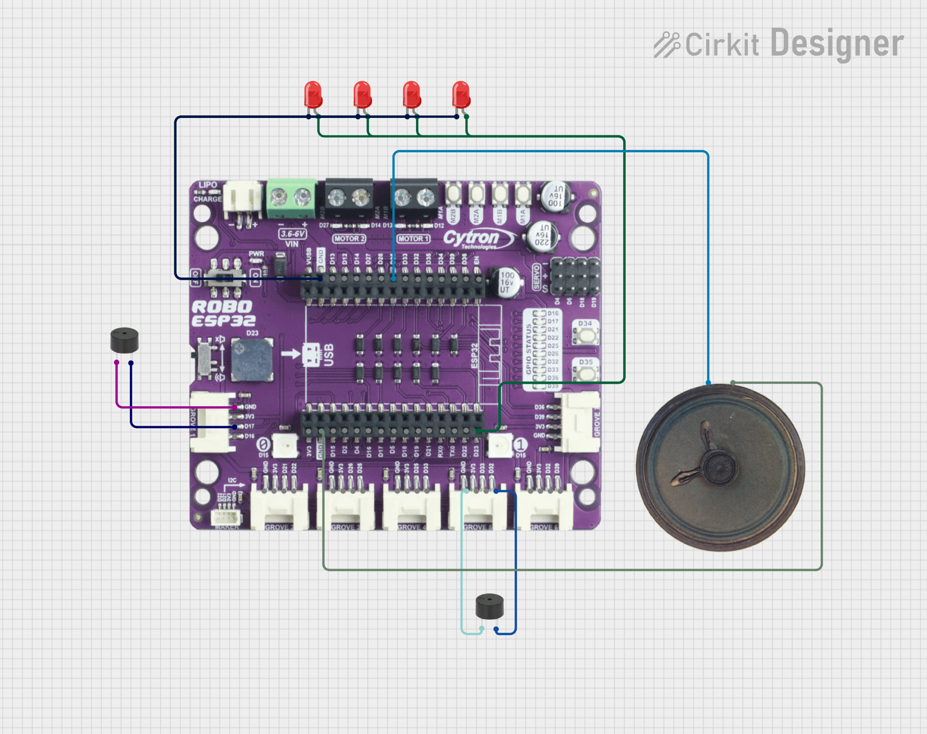
Fig. 6 Slave MCU Circuit

3. RESULT AND DISCUSSION
3.1 System 1 (Lighting System) Analysis
System 1 basically uses the LDR (light dependent resistor) to continuously measure ambient light intensity by providing an analogue voltage corresponding to the surrounding brightness. When the environment becomes dark, the LDR value decreases, indicating insufficient lighting conditions. When the detected light level falls below a predefined threshold, the system interprets the environment as dark and triggers the lighting response. This system ensures the safety for the blind people as the other people can see him in the dark place.
Upon detecting low-light conditions, the master ESP32 transmits a control signal wirelessly to the slave ESP32. The slave ESP32 then activates the LED array integrated into the Sense Cap, providing an immediate light source for the surrounding people nearby. Conversely, when sufficient ambient light is detected, the system automatically deactivates the LEDs to conserve power and prevent unnecessary lighting. Fig. 6 shows the LED in the bright surrounding and Fig. 7 shows LED in the dark surrounding.

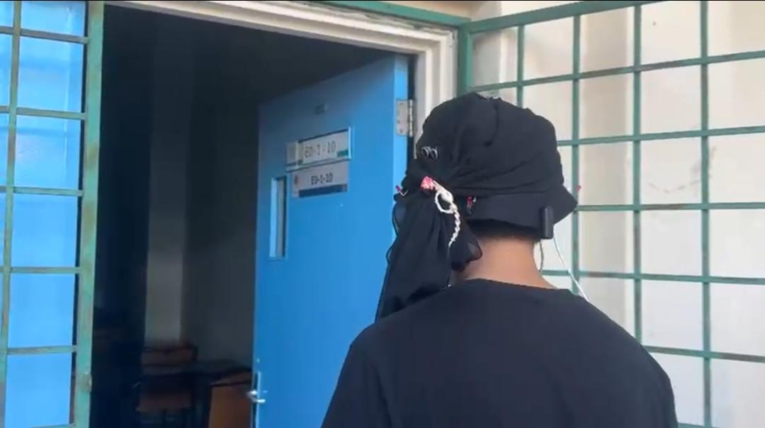
Fig. 7 Bright Surrounding

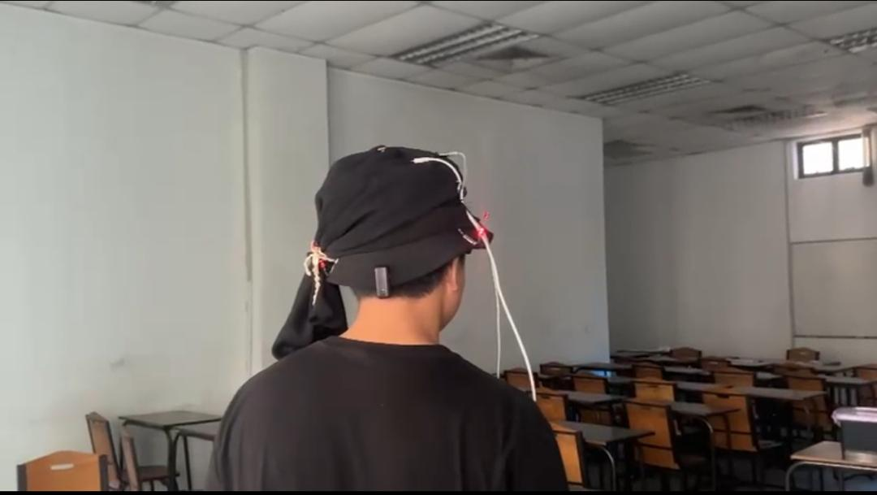
Fig. 8 Dark Surrounding

3.2 System 2 (Emergency Alert System) Analysis
The Emergency Alert System in SenseCap works when the user presses the Emergency Button on the headwear. Once pressed, the ESP32 sends a message through a Telegram Bot to tell the caretaker that the user is in an emergency and needs help right away. At the same time, it also sends the user’s GPS location so the caretaker can see exactly where they are. This lets the caretaker respond quickly, even if the user cannot speak or move safely.
After the button is pressed, the ESP32 sends both the alert and the GPS link almost instantly. The caretaker gets the message and location within seconds. Tests show the GPS is accurate and updates in real time. The system works reliably in different locations. This makes sure help can reach the user fast when it’s needed most.
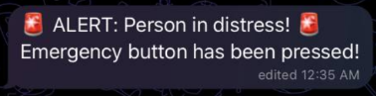
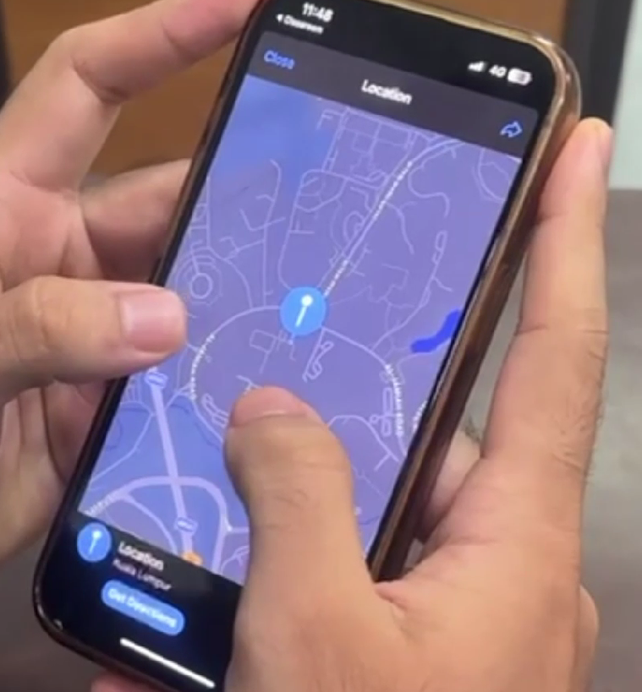
Fig 9. Telegram message and GPS location sent to caretaker

The Emergency Alert System gives extra safety that normal mobility aids cannot. Real-time alerts and location tracking let the user call for help immediately and let the caretaker reach them without delay. This makes SenseCap not just a navigation tool but also a safety device that helps visually impaired users move more confidently and independently.

3.3 System 3 (Obstacle Detection System) Analysis
Under System 3 (Obstacle Detection System), a series of tests were conducted to evaluate the performance of the ultrasonic sensors in detecting obstacles at varying distances and directions. The system utilizes three ultrasonic sensors positioned at the left, front, and right sides to provide directional obstacle awareness. Two buzzers are integrated as feedback mechanisms, with one placed on the left and the other on the right to indicate the location of detected obstacles.
The obstacle detection range was configured up to 150 cm, based on the assumption that the user walks at an average speed of 1 m/s. This range provides approximately 1.5 seconds of reaction time, which is sufficient for the user to perceive the warning and respond safely. When an obstacle is detected at a distance of 150 cm, the buzzer begins to emit a slow intermittent sound as an early warning. As the detected distance decreases, the buzzer frequency increases at intervals of every 15 cm, providing progressively faster auditory feedback. When the obstacle reaches a critical close range, the buzzer produces a continuous sound to alert the user of immediate danger.
Directional feedback is implemented to enhance spatial awareness. When the front ultrasonic sensor detects an obstacle, both left and right buzzers are activated simultaneously, indicating a direct obstruction ahead. If an obstacle is detected by the left ultrasonic sensor, only the left buzzer is activated, while detection by the right ultrasonic sensor triggers only the right buzzer. This configuration allows the user to intuitively identify the direction of nearby obstacles without visual input.
The test results demonstrate that the ultrasonic sensors are responsive and reliable in detecting obstacles within the defined range. The gradual increase in buzzer frequency effectively communicates proximity information, while the directional buzzer activation improves situational awareness. Overall, the obstacle detection system performs effectively in providing real-time distance and direction feedback, making it suitable for assisting users in navigating their surroundings safely.

Table 2: Obstacle Detection System Response Based on Distance and Direction
Distance (cm) | Detected Sensor | Left Buzzer Status | Right Buzzer Status | Buzzer Pattern
150 | Front | Active | Active | Slow beeping
90 | Front | Active | Active | Moderate beeping
60 | Front | Active | Active | Fast beeping
≤ 15 | Front | Active | Active | Continuous buzzer
150 | Left | Active | Inactive | Slow beeping
90 | Left | Active | Inactive | Moderate beeping
60 | Left | Active | Inactive | Fast beeping
≤ 15 | Left | Active | Inactive | Continuous buzzer
150 | Right | Inactive | Active | Slow beeping
90 | Right | Inactive | Active | Moderate beeping
60 | Right | Inactive | Active | Fast beeping
≤ 15 | Right | Inactive | Active | Continuous buzzer

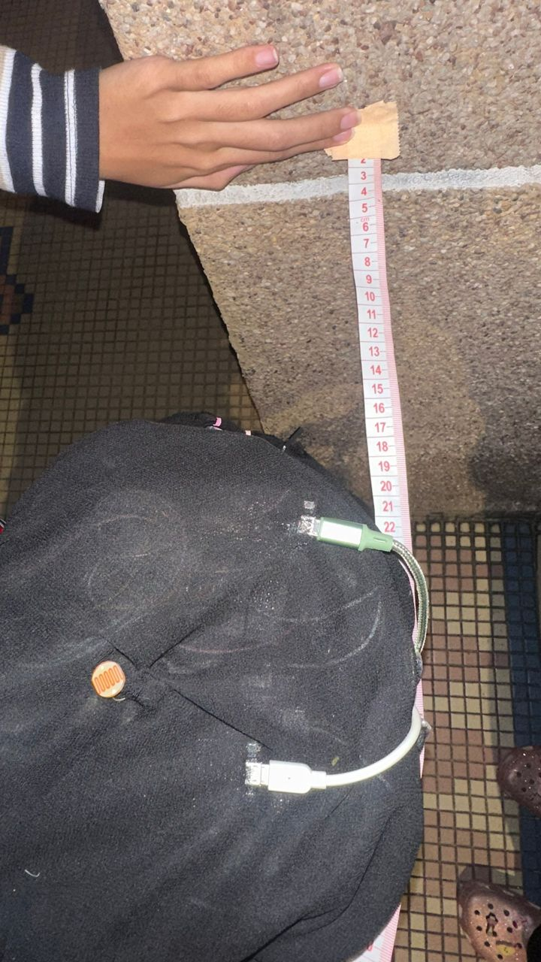
Fig 10: Distance of SenseCap from the wall (15cm - Continuous buzz)

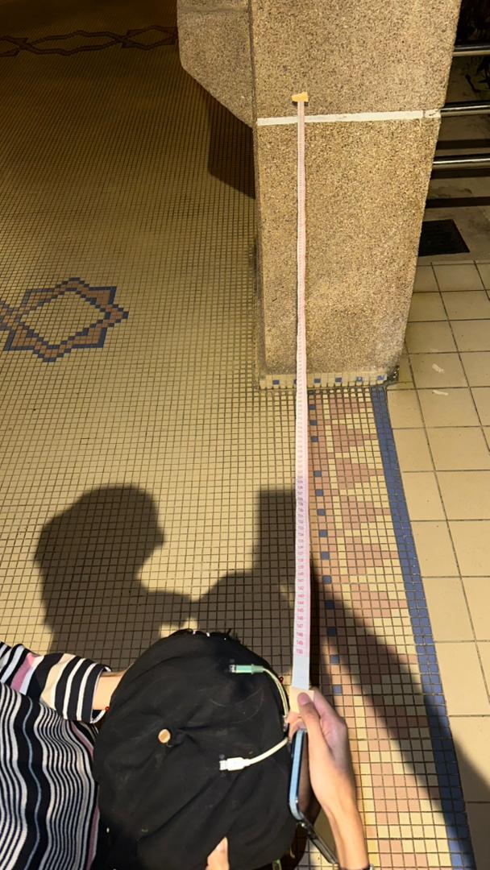
Fig 11: Distance of SenseCap from the wall (150cm - Slow beeping)

3.4 System 4 (Fall Detection System) Analysis
System 4 focuses on detecting fall incidents using the MPU6050 inertial measurement unit by monitoring acceleration changes in real time. The fall detection mechanism is based on the calculation of the total acceleration magnitude derived from the three-axis acceleration data (X, Y and Z). Two threshold conditions were implemented to identify fall events: a high-impact threshold of 2.5 g to detect sudden impacts, and a free-fall threshold of 0.5 g to detect brief weightlessness before impact. These conditions allow the system to detect both abrupt collisions and loss of support commonly associated with falling events.
During testing, fall scenarios were intentionally simulated by pushing the person wearing the device, while normal movements such as standing and walking were also observed for comparison. When the total acceleration exceeded the fall threshold or dropped below the free-fall threshold, the system immediately classified the event as a fall without any noticeable delay. Upon detection, an alert message was sent to a designated caretaker via Telegram, followed by the transmission of the user’s real-time GPS location. To prevent repeated alerts caused by consecutive movements after a fall, a cooldown period of 10 seconds was applied before allowing another detection.
The experimental results indicate that the fall detection system is reliable and responsive in distinguishing between normal movements and actual fall events. Normal activities produced acceleration values close to 1 g and did not trigger any alerts, while simulated falls consistently exceeded the predefined thresholds and successfully activated the emergency notification system. This confirms the effectiveness of the MPU6050-based fall detection approach in providing timely and accurate emergency alerts.

Table 5: Fall Detection Results Based on Acceleration Magnitude (MPU6050)
Test Case | Motion Condition | Measured Total Acceleration (g) | Threshold Exceeded | Fall Detected | System Response
1 | Normal standing / walking | ~0.9 – 1.1 | No | No | No alert
2 | Slight movement / tilt | ~1.2 – 1.6 | No | No | No alert
3 | Sudden push (simulated fall) | ≥ 2.5 | Yes (Fall threshold) | Yes | Telegram alert + GPS location sent
4 | Hat entering free-fall | ≤ 0.5 | Yes (Free-fall threshold) | Yes | Telegram alert + GPS location sent
5 | Repeated fall within cooldown | ≥ 2.5 | Yes | No | Ignored (cooldown active)

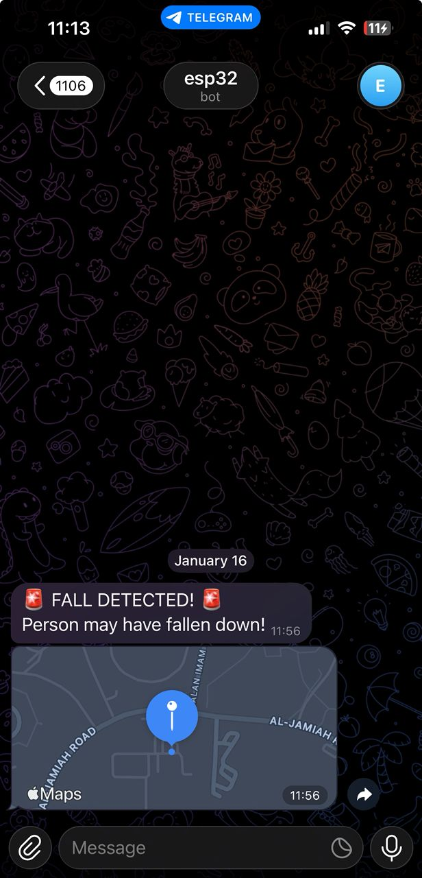
Fig. 12 Showed the System is activated and send the locations of user.
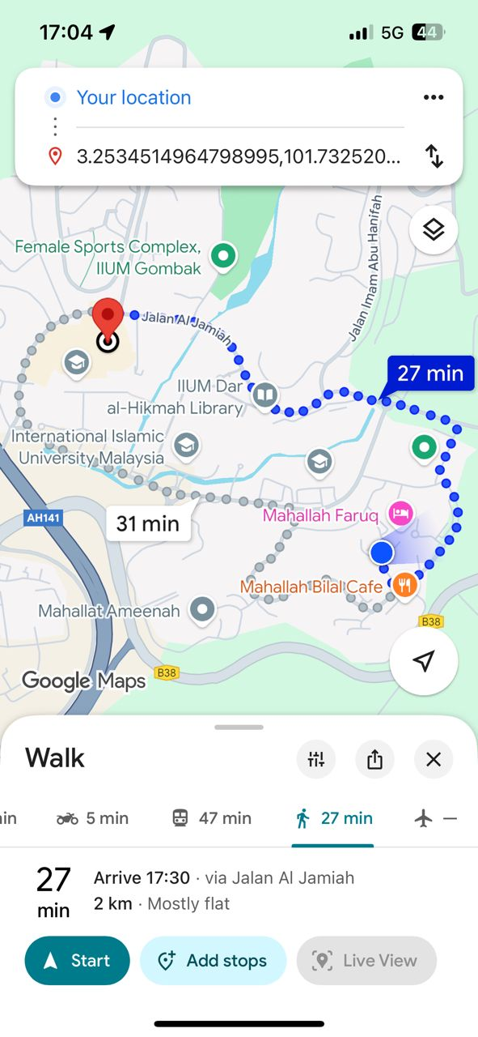
Fig. 13 GPS Location by Google Maps

3.5 System 5 (Colour Detection System) Analysis
The colour detection system uses the HuskyLens vision sensor to identify traffic light signals, which helps visually impaired people cross the street. The HuskyLens continuously records and evaluates visual information from its surroundings while in colour recognition mode. The sensor sends the matching colour data to the Master ESP32 for processing and decision-making when a traffic light colour is identified.
The Master ESP32 classifies the detected traffic light colour into one of four predetermined categories which are Red, Yellow, Green, or Blue after receiving the colour detection data. Every colour is given a unique control code, which is then wirelessly sent via ESP-NOW communication to the Slave ESP32. Using a speaker, the Slave ESP32 then transforms the incoming command into a suitable auditory feedback signal. Yellow produces a rising anticipation tone to indicate caution and preparedness, Green produces a confident ascending tone to indicate it is safe to cross the road, Red produces an urgent alternating warning tone to indicate danger and instruct the user to stop, and Blue provides a neutral informational tone. Each audio signal is designed to last approximately three seconds to ensure clarity and sufficient response time for the user.
A cooldown technique is used to limit the replay of repeated auditory notifications while the colour of the traffic light stays the same. The HuskyLens was subjected to simulated traffic light situations under normal light conditions in order to conduct experimental testing. Real-time traffic light colour detection was accomplished by the system, and the relevant audio notifications were immediately activated. The outcomes show that the colour detection system converts visible traffic signals into meaningful sounds in a dependable, responsive, and efficient manner. This demonstrates the system's viability as a device that assists to improve visually impaired users' safety when crossing the road.

Table 6: Traffic Light Colour Detection and Audio Feedback Mapping
Traffic Light Colour | Colour Code (ID) | Audio Feedback Description | User Instruction
Red | 1 | Urgent alternating warning tone | Stop-Do not cross
Yellow | 4 | Rising anticipation tone | Prepare to cross
Green | 2 | Confident ascending tone | Safe to cross
Blue | 3 | Neutral informational tone | System status / information

4. CONCLUSION
This project successfully designed and implemented SenseCap, a multifunctional assistive headwear aimed at improving the safety, mobility, and independence of visually impaired users. By integrating multiple sensing and communication subsystems into a single wearable platform, SenseCap addresses several limitations of conventional mobility aids such as white canes and basic smart devices.
The system effectively combines ultrasonic obstacle detection, automatic LED lighting, fall detection using an MPU6050 IMU, emergency alert and GPS location sharing via Telegram, and traffic light colour recognition using a vision sensor. Experimental testing demonstrates that each subsystem performs reliably with fast response times and consistent behaviour under real-world conditions. The obstacle detection system provides clear directional and proximity feedback, the lighting system enhances user visibility in low-light environments, and the fall detection and emergency alert systems ensure timely assistance during critical situations. Additionally, the colour detection system successfully converts visual traffic signals into meaningful auditory cues, significantly improving road-crossing safety.
The layered system architecture, which separates real-time sensor control and higher-level processing, proved effective in maintaining system stability while managing multiple tasks simultaneously. Overall, SenseCap demonstrates a practical, low-cost, and wearable solution that enhances situational awareness and user safety without relying heavily on complex or power-intensive technologies.
Future improvements may include the integration of GPS-based navigation guidance, voice command interaction, battery optimization, weather-resistant housing, and advanced object recognition algorithms. With further refinement, SenseCap has strong potential to be developed into a robust assistive technology for everyday use by visually impaired individuals.

Acknowledgement
The authors acknowledge the guidance provided by Dr Zulkifli with his impeccable knowledge in this field. We also thank Br. Harith with his assistance in correcting our work thus leading to a successful experiment.
Conflict of Interest
Authors declare that there is no conflict of interest regarding the publication of the paper.

Author Contribution
The author attests to having sole responsibility for the following: planning and designing the study, data, collection, analysis and interpretation of the outcomes, and paper writing.

REFERENCES
[1] World Health Organization, World Report on Disability, WHO Press, Geneva, Switzerland, 2020.
[2] A. V. Nandini, A. Dwivedi, N. A. Kumar, T. S. Ashwin, V. Vishnuvardhan, and R. M. R. Guddeti,
“Smart Cane for Assisting Visually Impaired People,” Proceedings of the IEEE Region 10 Conference (TENCON), Kochi, India, 2019, pp. 546–551, doi: 10.1109/TENCON.2019.8929579.
[3] D. Dey, S. Saha, A. Chowdhury, and S. K. Das,
“Ultrasonic Based Smart Navigation System for the Visually Impaired,” International Journal of Engineering Research & Technology (IJERT), vol. 6, no. 5, pp. 227–231, 2017.
[4] Gbenga, O. A.,
“Design and Construction of a Smart Walking Stick for the Blind,” International Journal of Engineering and Computer Science, vol. 5, no. 2, pp. 15702–15709, 2016.
[5] HuskyLens AI Vision Sensor,
“Colour Recognition and Object Detection Documentation,” DFRobot, 2023.
[6] OrCam Technologies Ltd.,
“OrCam MyEye: Assistive Vision Device for the Blind,” Product Documentation, 2020.
[7] Envision Technologies B.V.,
“Envision Glasses: AI-Powered Assistive Technology for the Visually Impaired,” Product Overview, 2021.
[8] Y.-H. Liu, H.-Y. Su, H.-C. Lin, C.-Y. Li, Y.-H. Wang, and C.-H. Huang,
“Investigation of Achieving Ultrasonic Haptic Feedback Using Piezoelectric Micromachined Ultrasonic Transducers,” Electronics, vol. 11, no. 14, p. 2131, 2022.
[9] M. F. Razali, S. F. Toha, and Z. Z. Abidin,
“Intelligent Path Guidance Robot for Visually Impaired Assistance,” Procedia Computer Science, vol. 76, pp. 330–335, 2015.

